

Red: Isometric Ca2+ transients for varying sarcomere length Blue: Work-loop Ca2+ transients for varying afterloads

Like before, the Isometric Ca2+ transients(red) have a longer duration than the Ca2+ transients for the work-loops(blue). So inserting an isometric ca2+ transient into the work-loop simulation would be worthwhile to see if greater isotonic shortening, and therefore more similar isometric and WL ES curves, may be achieved.

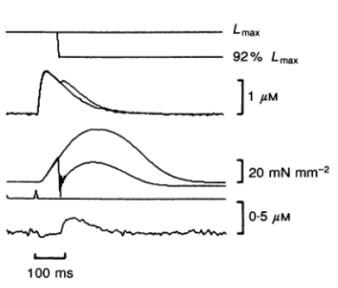

Here I am comparing my model (right) to the Kurihara quick-release experiment results (left). What I am noticing is that the quick change in sarcomere length results in only a very small bump in the intracellular Ca2+ transient, much smaller than the bump I was getting when I first recreated this experiment (see the following page). Because of this, the peak stress for the quick-release protocol(red) and non-quick-release protocol(blue) does not differ by much.

|  |  |
| --- | --- |
| Figure |  |

Old Kurihara/ Megan-model quick-release comparison.

